**Lambda functions:**

First we perform a basic addition expression using lambda. Here we are using simple addition expression that adds the values of a, b and c.

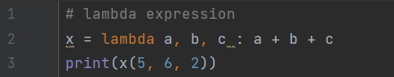

**Output:**

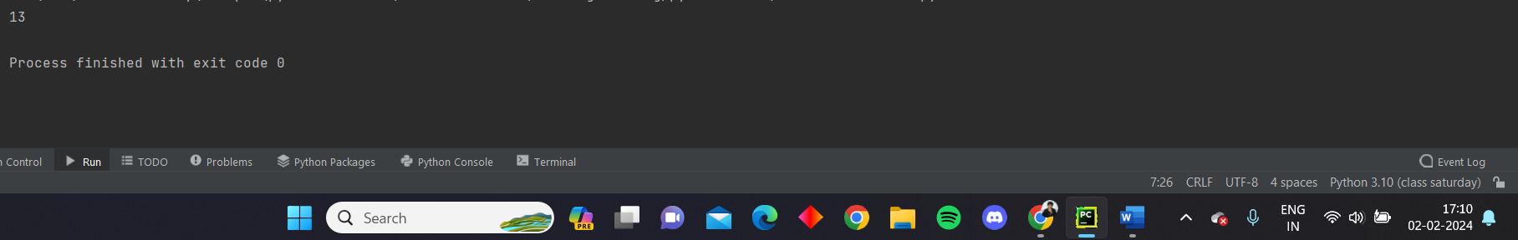

**Upper**

Now we use the lambda expression to convert the characters in a string into upper case by using the upper() function. Here the string ‘Roshan’ is passed to the lambda expression which uses the upper() function to change all the letters in the string into upper case.

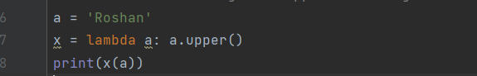

**Output:**

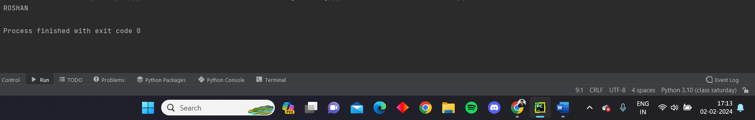

**If else**

We can also perform if else conditions in lambda function. In the below code we used the if else condition along with lambda expression to find the maximum number between two numbers.

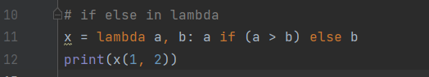

**Output:**

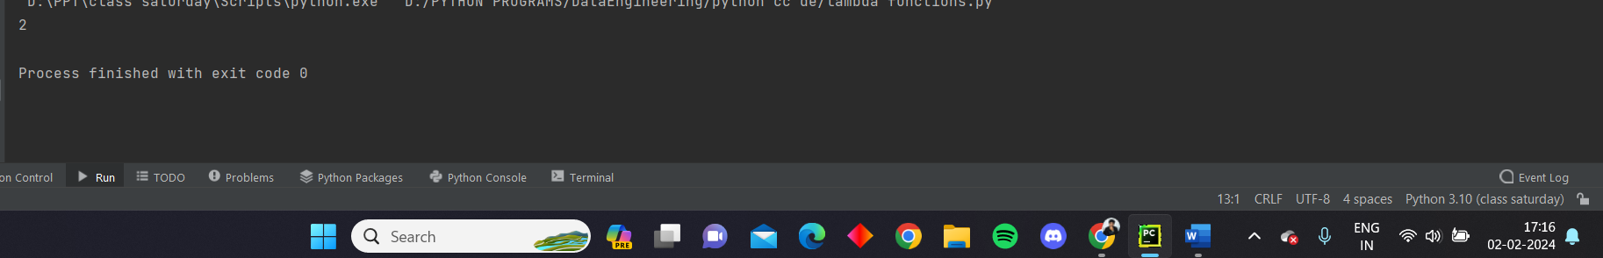

**Filter**

We can use filter function along with lambda expression. Here we have list named ‘age’ which has some values, we use the lambda expression to filter the values that are less than 18 and convert them into another list. By this with all the condition satisfied values a new list will be created.

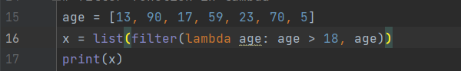

**Output:**

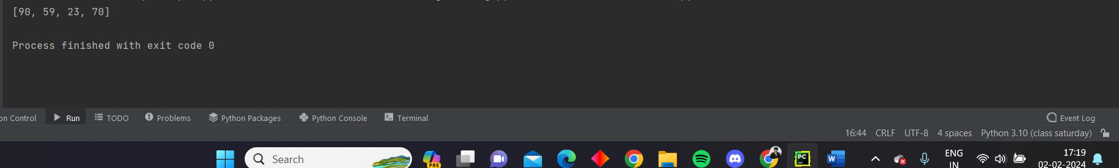

**Map**

We can use the map function along with lambda. Here we took a list ‘l’ we multiplied each value in the list with 2 and converted into a map. Then it is further converted into a list.

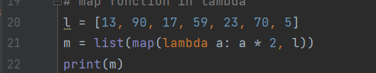

**Output:**

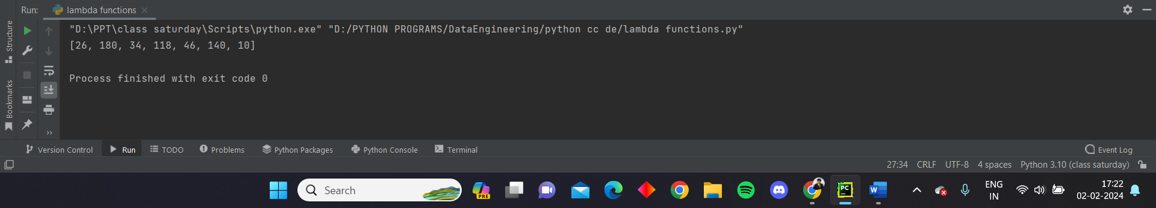

**Reduce**

We can also use the reduce function along with the lambda expression. For doing that first we need to import the reduce function from functools. Then we created a list of values, as we need the sum of all the values present in the list, we used the reduce function. Here the reduce function will add the first two values initially, then adds the sum with the third value. This process continues till the end of the string and the total sum will be returned.

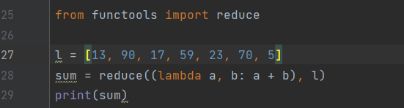

**Output:**

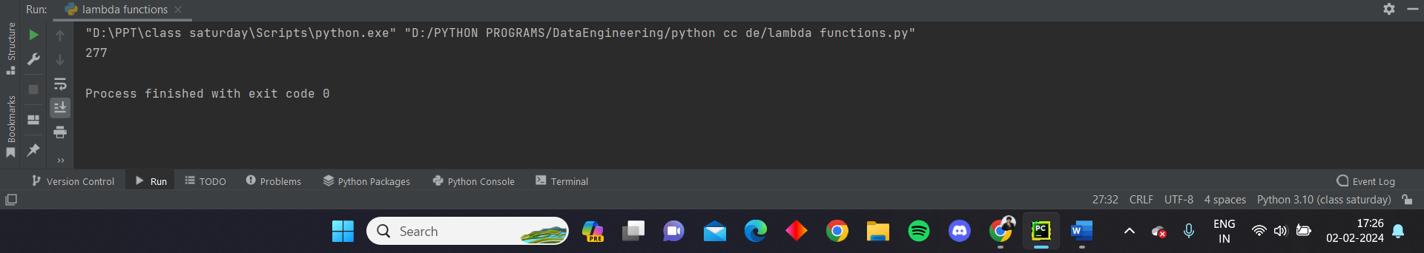

**Reading Json files into python dict or list**

We need to first import the json module to perform any operations based on json. We took a sample json string ‘x’ then we converted the json string into python dictionary using the json loads function. We assigned the dictionary to a variable called json_dict.

This json_dict will contain the dictionary that is converted from json string.

The we also fetched the list that is present in the dictionary by using a key from the dictionary converted from json string.

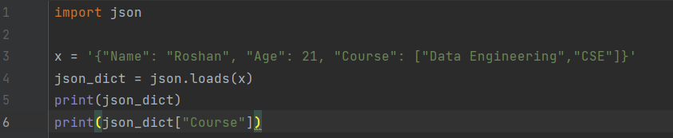

**Output:**

